Circumference Practice Problems Name:_______________

1. What is the best estimate of the circumference of a circle with a diameter of 12? Justify your choice.
a) 6 cm
b) 18 cm
c) 36 cm

2. Estimate the circumference of a circle with ;
a) a radius of 3.5cm __________________
b) a radius of 10.5 cm __________________
c) a diameter of 21 __________________
d) a diameter of 42 __________________

3a)What is the diameter of the Canadian toonie?  b) ESTIMATE the circumference of the Canadian toonie?  c)What is the exact circumference of the Canadian toonie? | 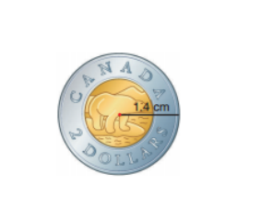

4. An above-ground swimming pool has a diameter of 8.5 m. If Joe wants to put a fence around the edge of his pool, how much fencing will he need?

5. a)George's parents are buying a new circular dining room table.
They want the table large enough to seat 8 people so that each
person has 60 cm of table space along the circumference. What
should the diameter of the table be?

b)By how much the diameter change if George's parent decide to
reduce seating space to 45 cm?

6. Calculate the circumference of each circle. Give the answers to two decimal places. Estimate to check the answers are reasonable.
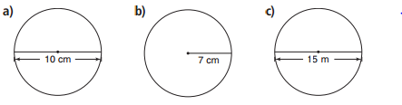

7. Calculate the diameter and radius of each circle. Give the answers to two decimal places.
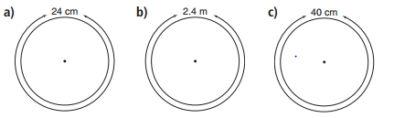

8. Ali’s school has a running track that is semi‐circular at each end, as shown. The straight sides are 60 metres and the track is 32 metres wide. About how many times does he have to go around the track to run 2 km?

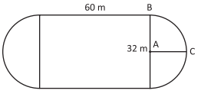

9. Estimate how many strokes it would take for Assoun to swim around the edge of a pool, if it took him 30 strokes to swim across the widest part of a circular pool.

9 One whole pizza was sitting on top of the stove. Jacinthe cut out a piece of pizza and ate it. The central angle of the missing piece was 45°. Lisette came by, sliced some pizza, ate it, and left. The central angle of the remaining pizza was 120°. How much of the pizza did Lisette eat?

11. A dog is tethered to a stake in a yard and can walk or run in a circle. The largest circumference of his runway is 56.52 m. What is the length of the dog’s tether rope? Explain your thinking.

